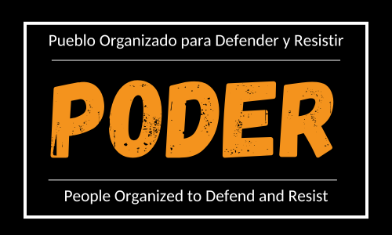

P.O.D.E.R.
Pueblo Organizado para Defender y Resistir - People Organized to Defend and Resist

TRANSLATOR AND INTERPRETER PROJECT (TIP)

The PODER Translator and Interpreter Project (TIP) utilizes community volunteers to interpret and translate for PODER activities including the Community Defenders Project, Community Resistance, and Telling Our Stories.

PODER's participatory defense model encourages participants to transform themselves from service recipients into change agents. To this end, TIP volunteers play an important role in reducing barriers to participation, and empowering Project participants to reciprocate and strengthen PODER's legal and community organizing efforts. Participatory defense aims to rebalance power disparities in legal systems and beyond, which means that TIP volunteers must be sensitive to the power relationships inherent in their role as interpreters.

Due to the nature of PODER's legal work, TIP volunteers may be interpreting information that is sensitive, difficult, or legally privileged. Volunteers must sign confidentiality agreements and understand that all the information that they learn while translating or interpreting is protected and confidential and may not be shared with anyone under any circumstances. People’s stories are theirs to tell. TIP volunteers may not share their stories without permission.

TIP Volunteers are asked to use humanizing language, respect client confidentiality, and commit to the participatory values of PODER. TIP volunteers must agree that language skills or lack thereof does not define capability or power. TIP volunteers must understand they are enabling people to share their message through language but they are not speaking for people who cannot speak for themselves. PODER will support TIP volunteers with additional training opportunities and meetings where we can all share concerns and resources.

PODER will engage TIP volunteers in the following activities:

TRANSLATORS

Translators are needed to translate documents, presentations and materials from English to Spanish. Examples of some of the items that need translating include:
- Birth, marriage and other civil documents (we provide templates for many of these)
- Declarations and statements
- Medical records, transcripts and other documents from foreign countries
- Community materials like Know Your Rights materials
- Web resources

INTERPRETERS

Interpreters are needed for the following:
- Conversations between people in removal proceedings and the attorneys
- Conversations between family members and the attorneys
- Community meetings and events
- Meetings with local officials
- Audio or video presentations

